**Assignment SDE**

Use source code from 'aesthisia-demo/' directory & use the src to build docker image for the same. To run the app, use command: 'npm start' Run the docker image on port 3000 & check the output on '[http://localhost:3000](http://localhost:3000/)'

**Tools and version required**

* Docker
* Git
* Port: 3000

**Lab – 1: Creating an EC2 Instance**

**1.**To create your EC2 instance, go to Amazon EC2 in the AWS console.

Click the button that says Launch instance to open the instance creation.

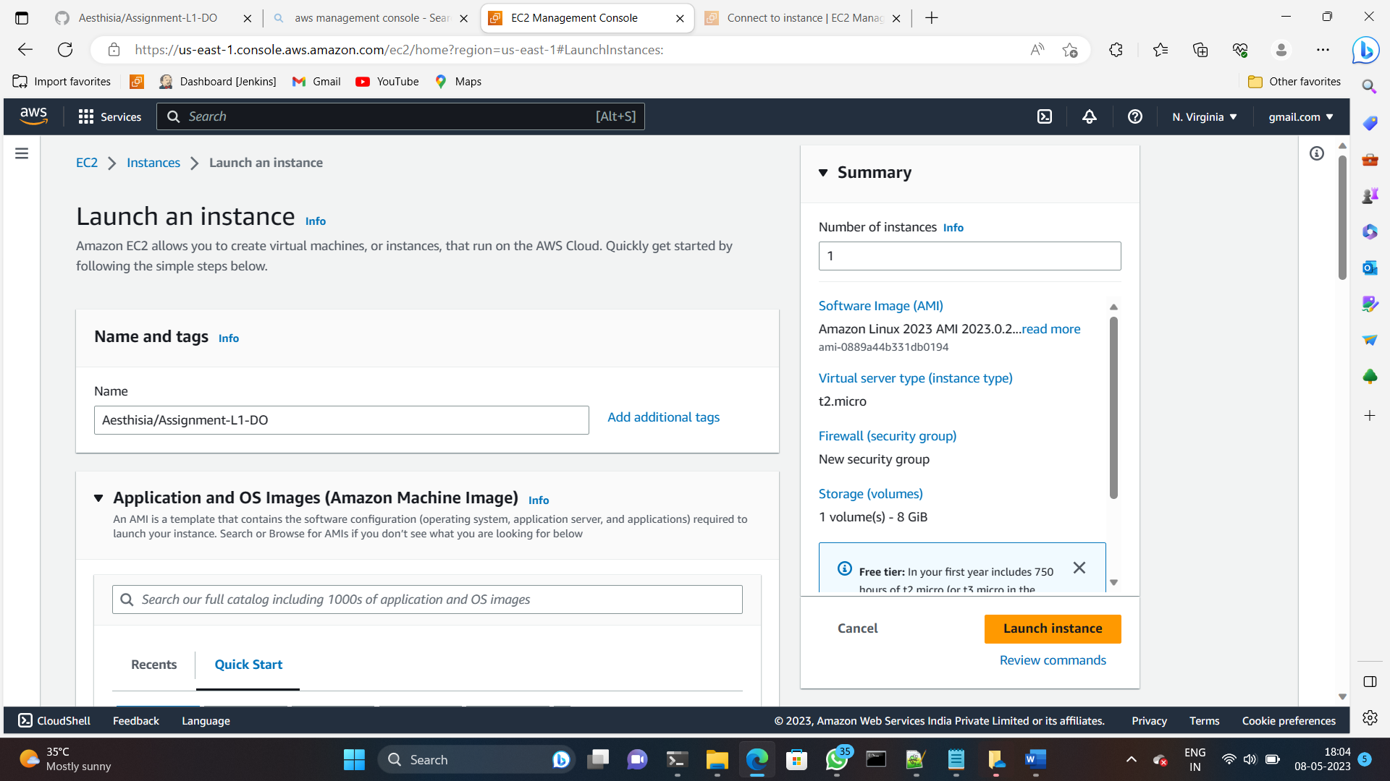

## I have given the instance name Aesthisia/Assignment-L1-DO

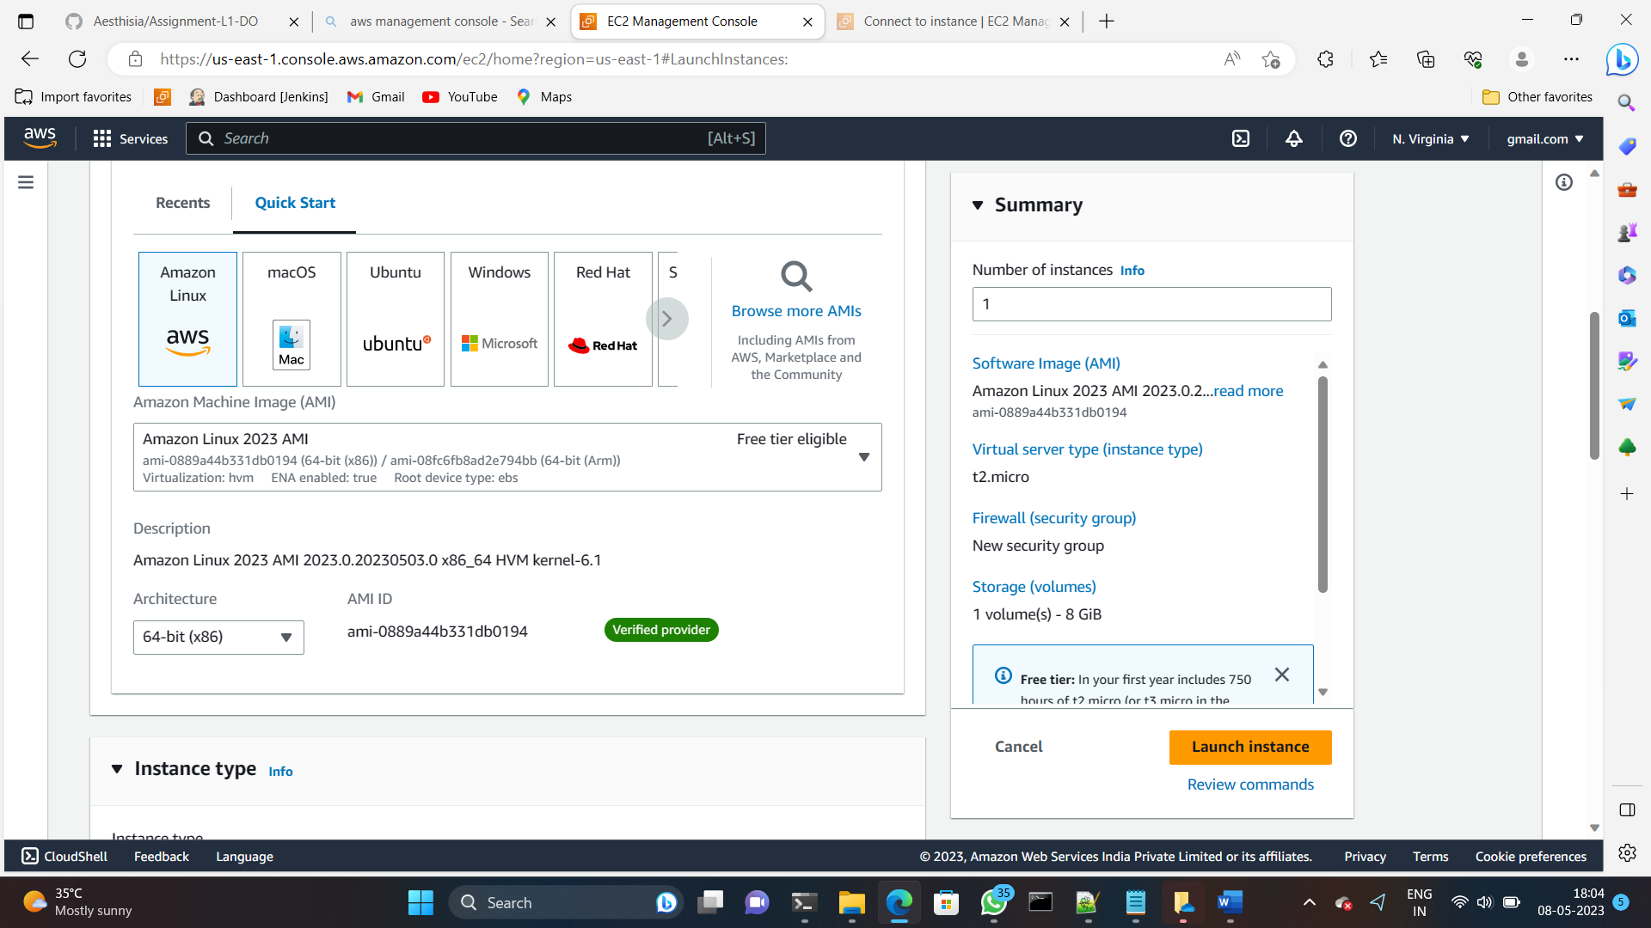

3. For this I choose the amazon linux operating system

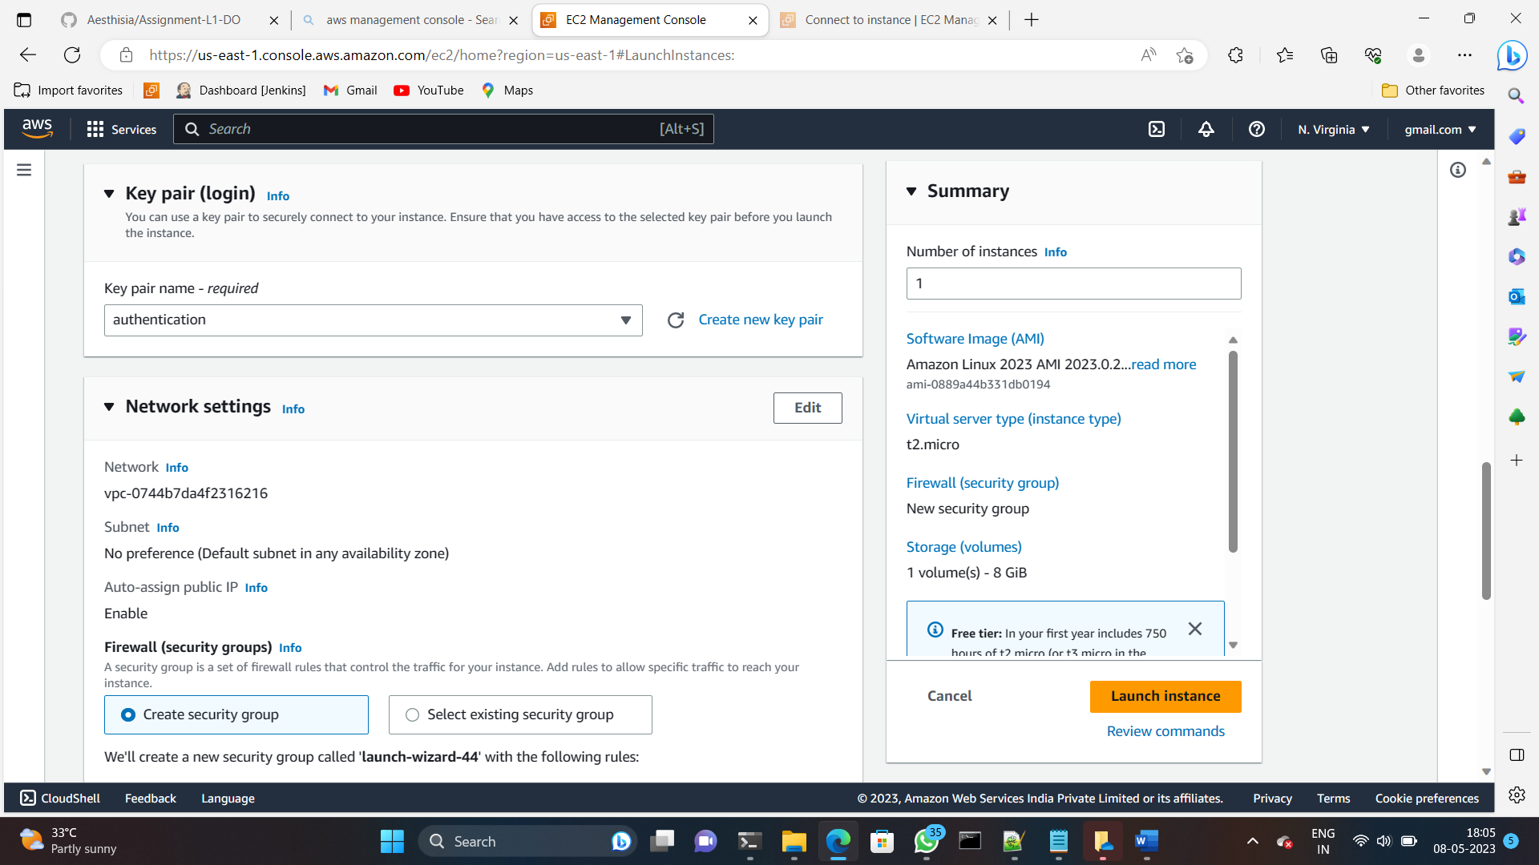

4. I have taken my existing key pair that is **authentication.pem**

5. Selected the existing security group with allowing port **3000**.

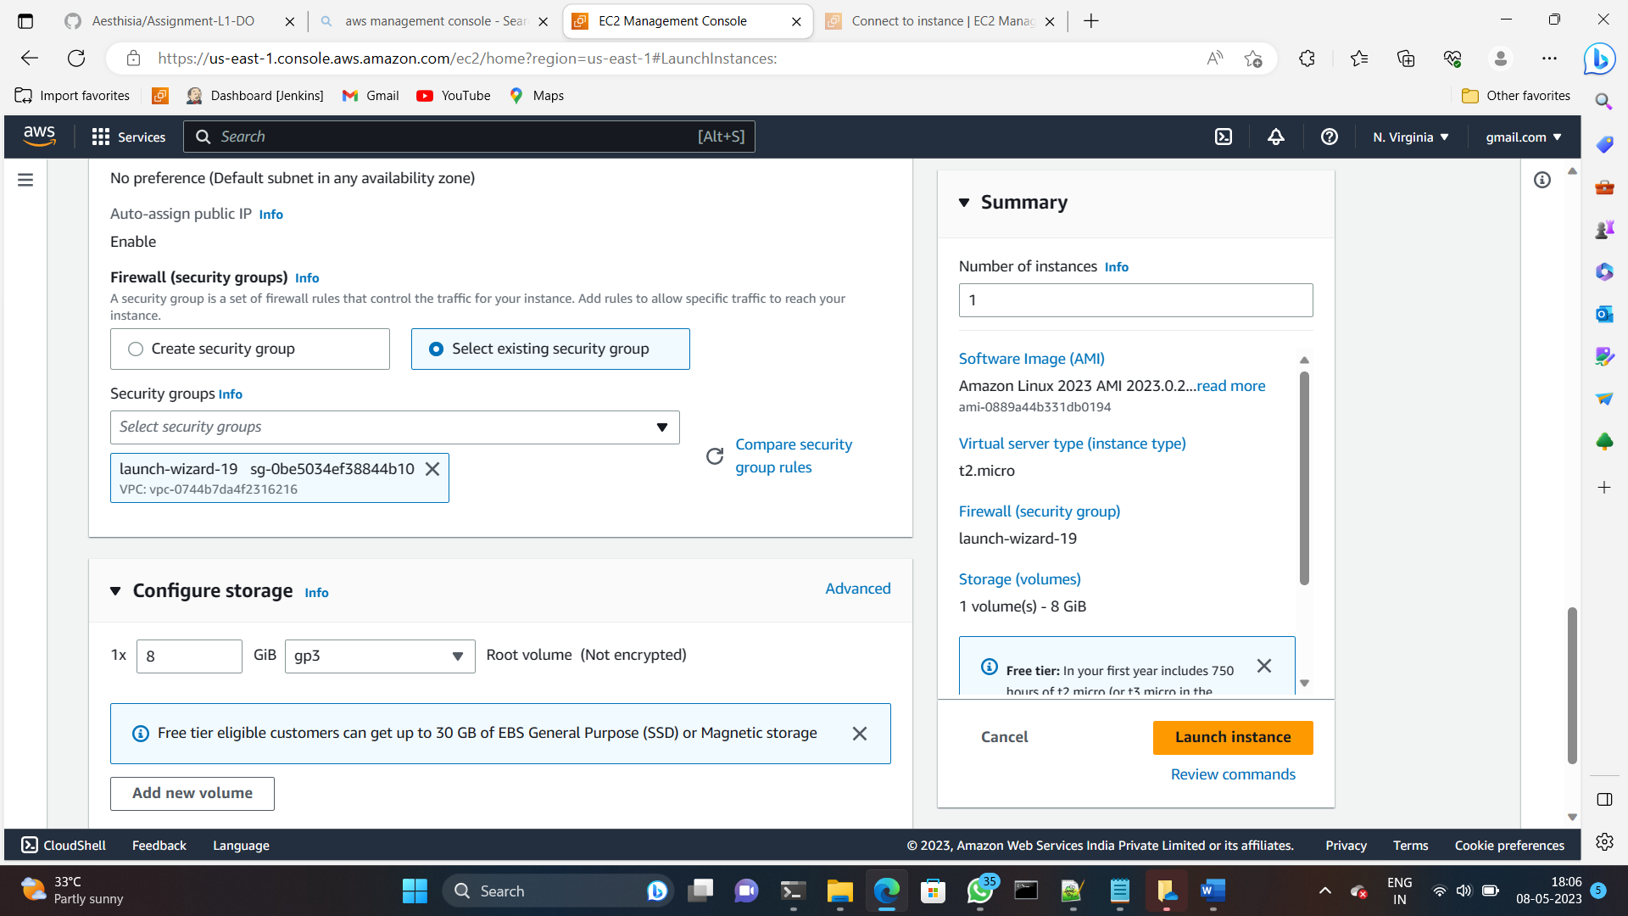

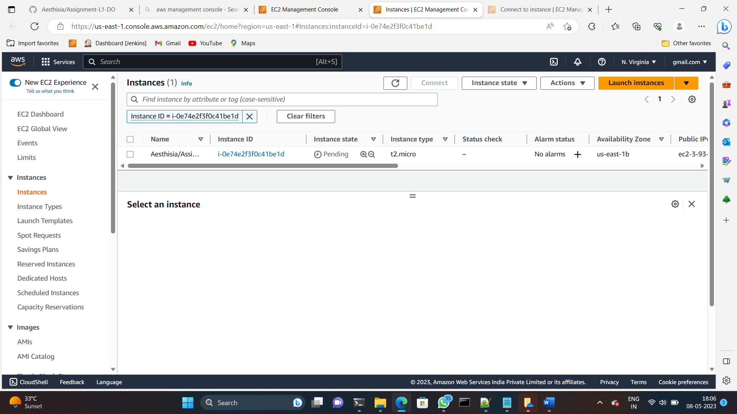

Successfully launched the ec2 instance.

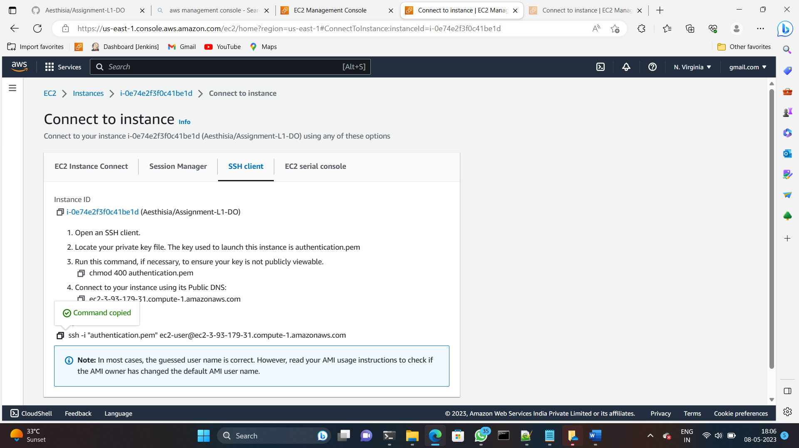

Copied the ssh address to connect to the terminal

**SSH into your EC2 Instance**

1. We are accessing the command line interface with ssh command

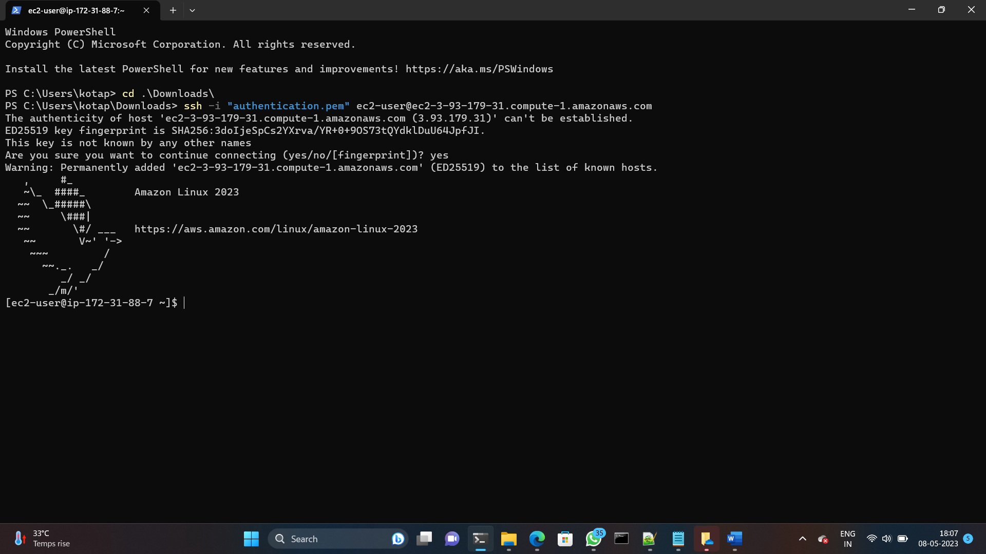

# Module – 2: Installing GIT, Docker, and related repos

1. we have to install the git and docker in our instance by using below commands.

* **sudo yum -y install git**

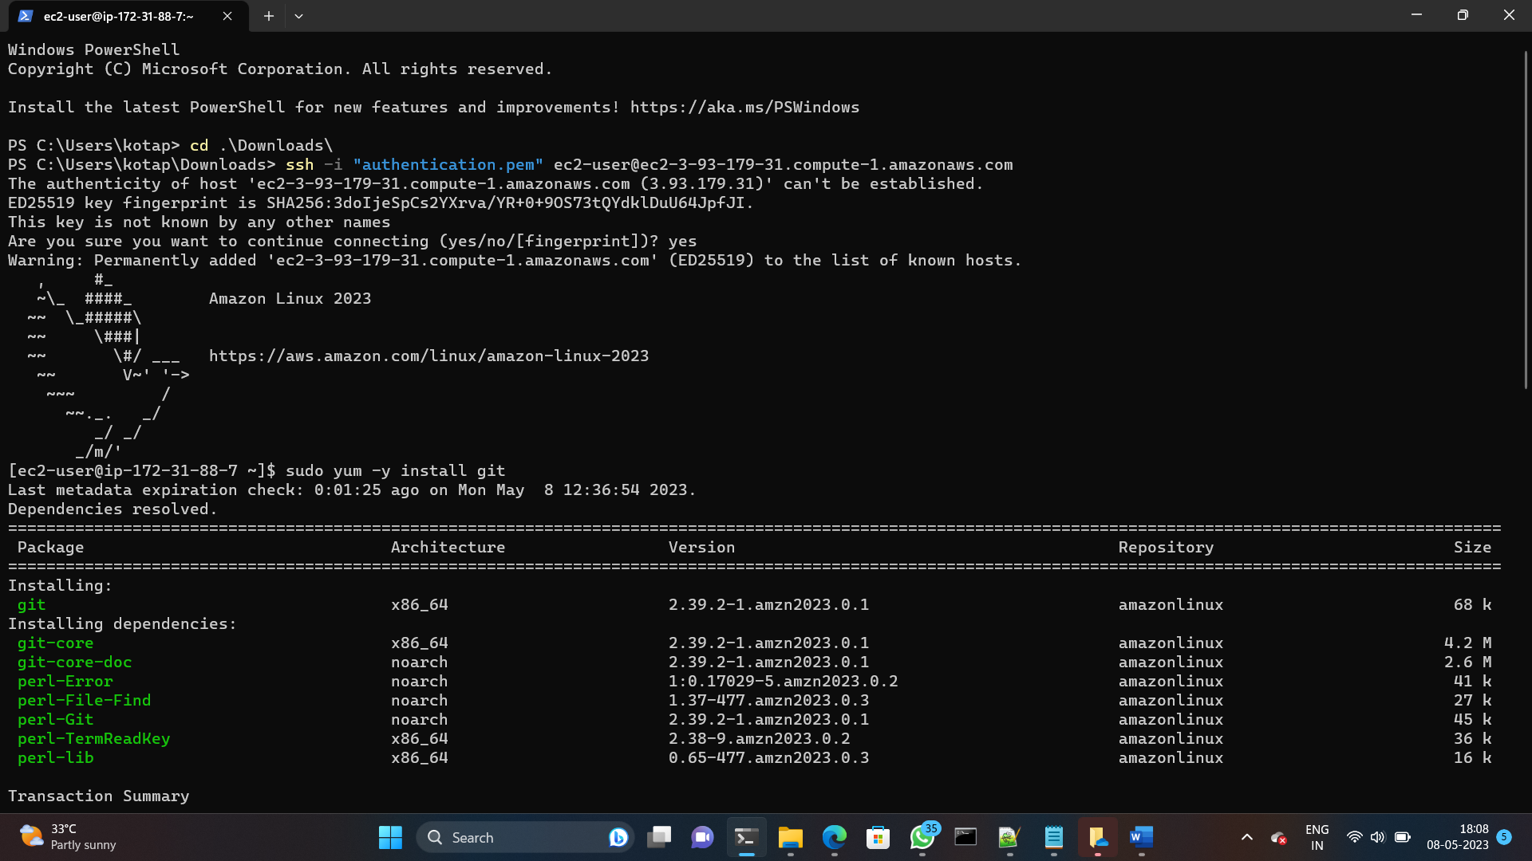

Installed the docker by using the below command.

* **sudo yum -y install docker**

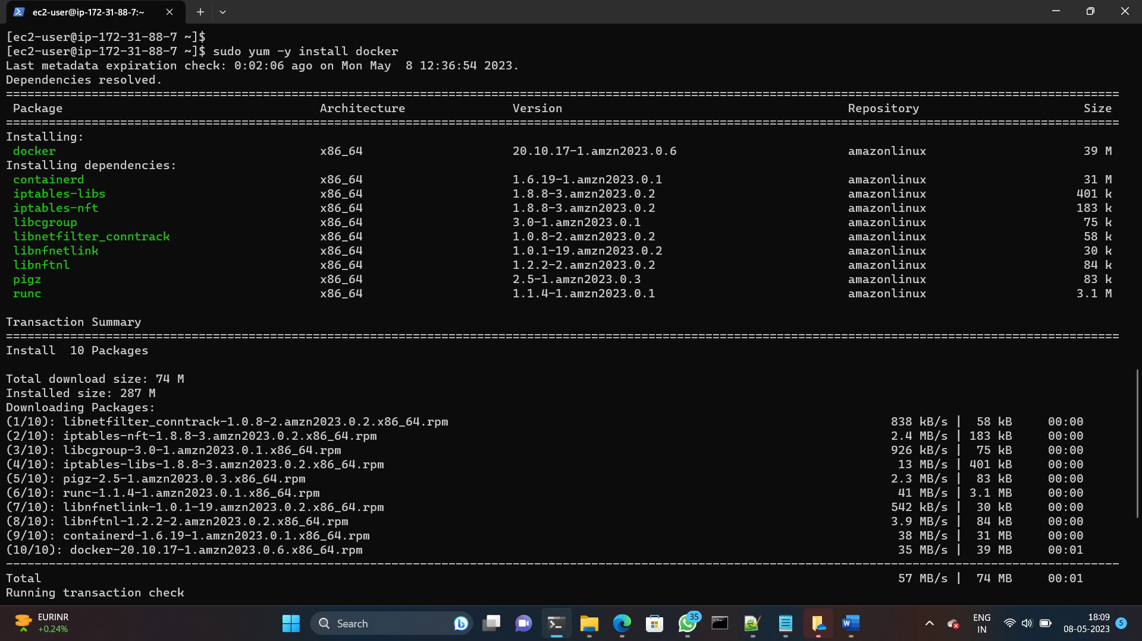

**Cloning project source code from github:**

* I copied the code from from github

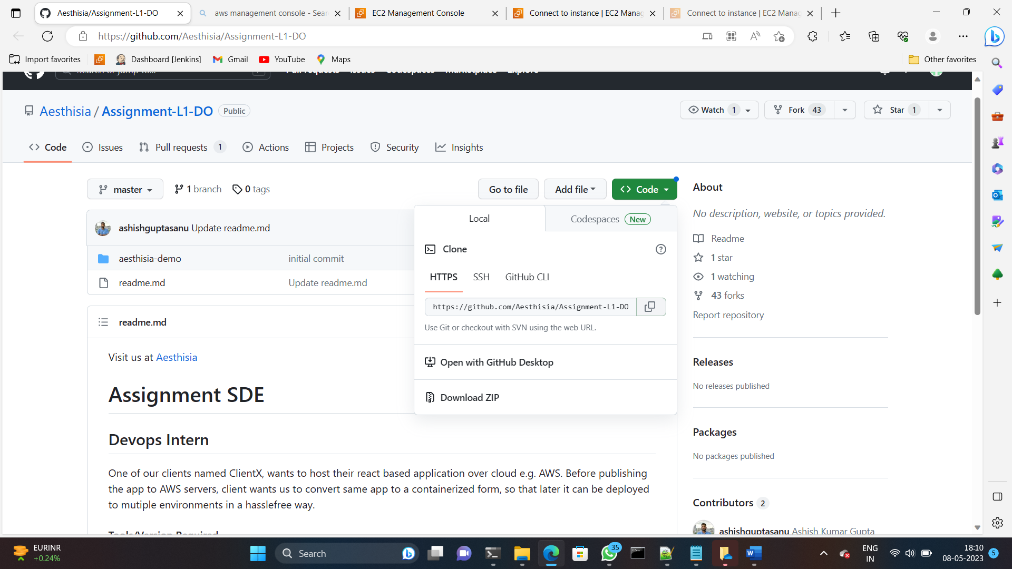

1. Cloned the project source code using the command.

* **git clone** [**https://github.com/Aesthisia/Assignment-L1-DO.git**](https://github.com/Aesthisia/Assignment-L1-DO.git)

1. change the directory to the project directory where your application code is located.
2. **cd Aesthisia/**
3. **cd aesthisia-demo/**

**start the docker service:**

1. After installing docker , start the docker service by running the following command .

* **sudo systemctl start docker**

1. Enable the docker service by running the following command .

* **sudo systemctl enable docker**

1. I haven given the permission to the docker demon in oder to work with docker by running the below command.

* **sudo chmod 666 /var/run/docker.sock**

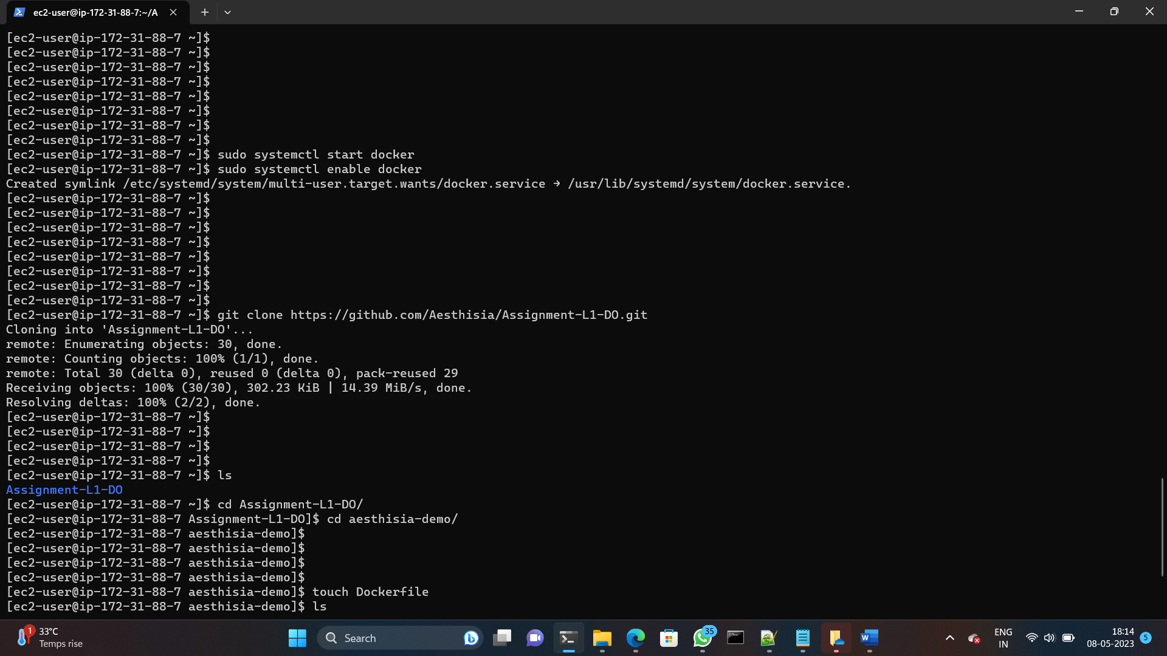

1. In project directory create a new file named “**Dockerfile**” by running the following command .

* **touch Dockerfile**

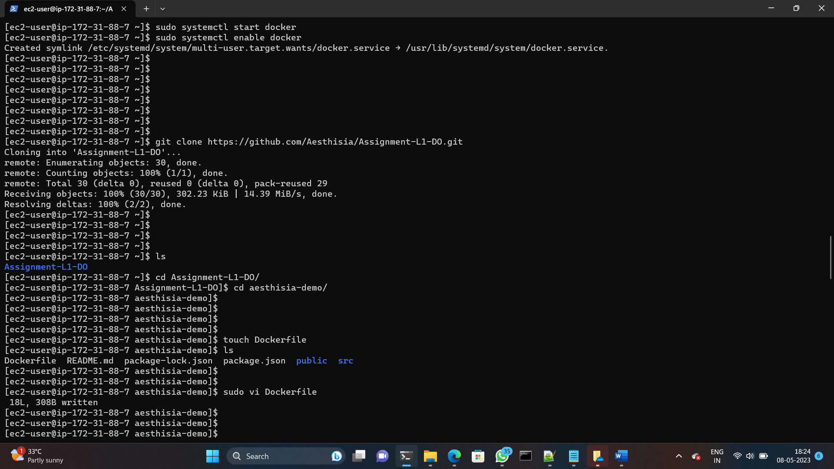

1. By using **sudo vi Dockerfile** command opened the vim editor.

1. Edit the Dockerfile and spcify the instructions for building the docker image.
2. You can see my dockerfile below.

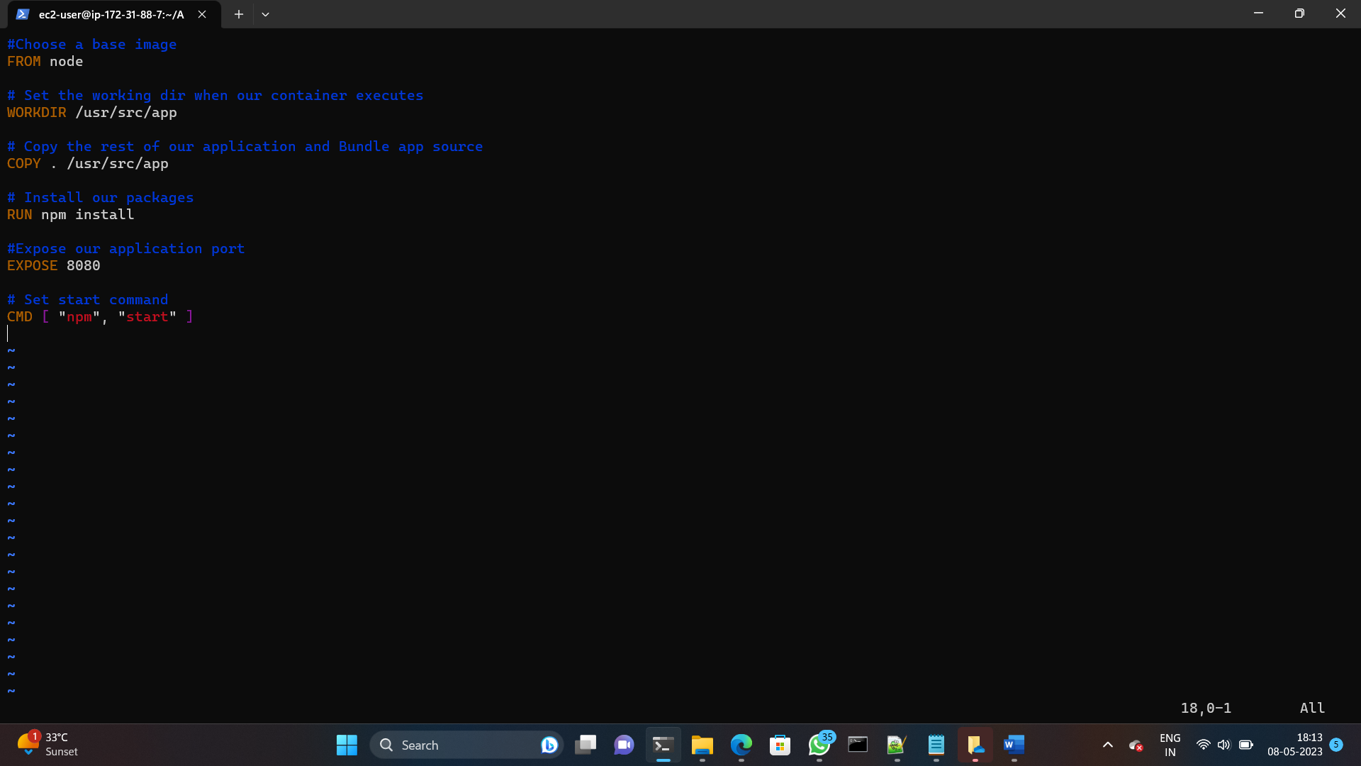

1. Save the docker file and exit the text editor by using **:wq!**.
2. After creating the dockerfile, run the following command to build the docker image.
3. The command to create docker image

* **docker build -t react .**

**react** is my image name

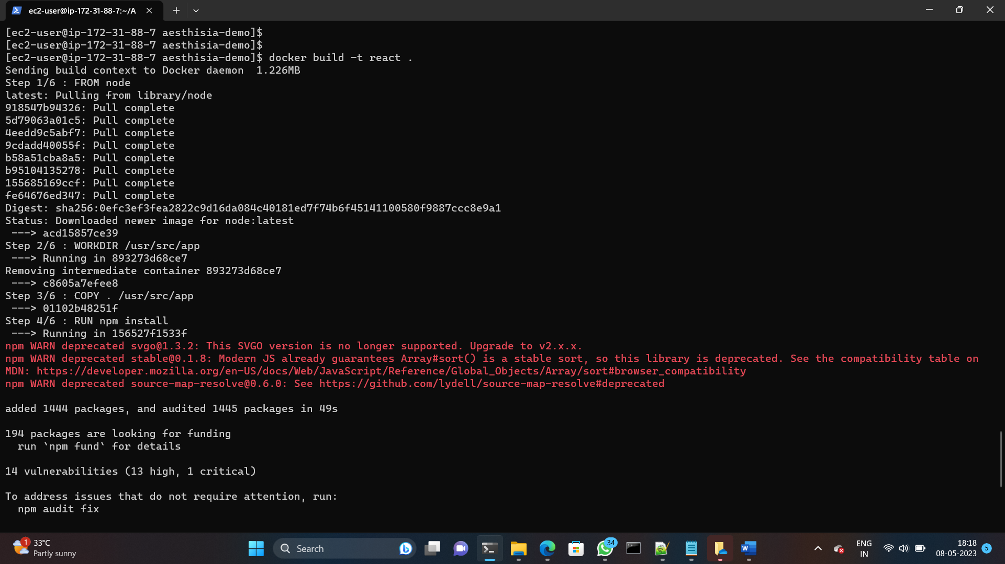

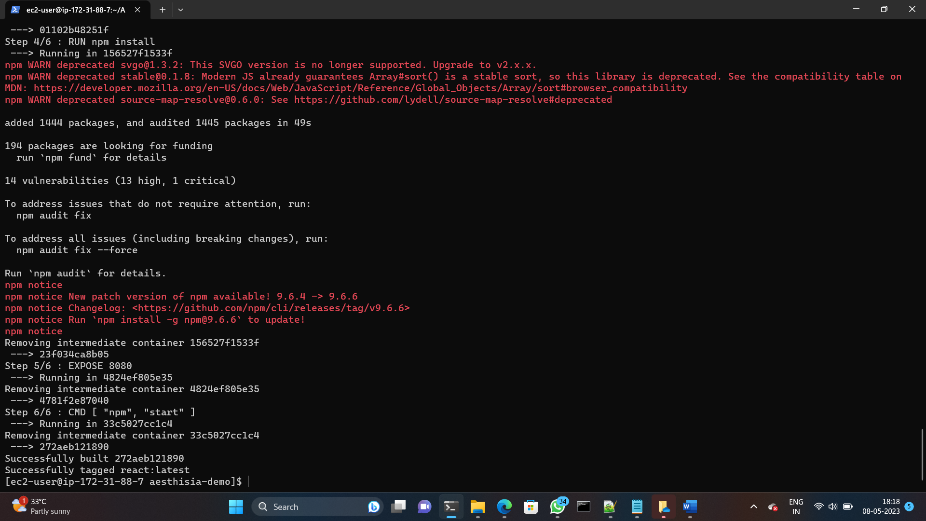

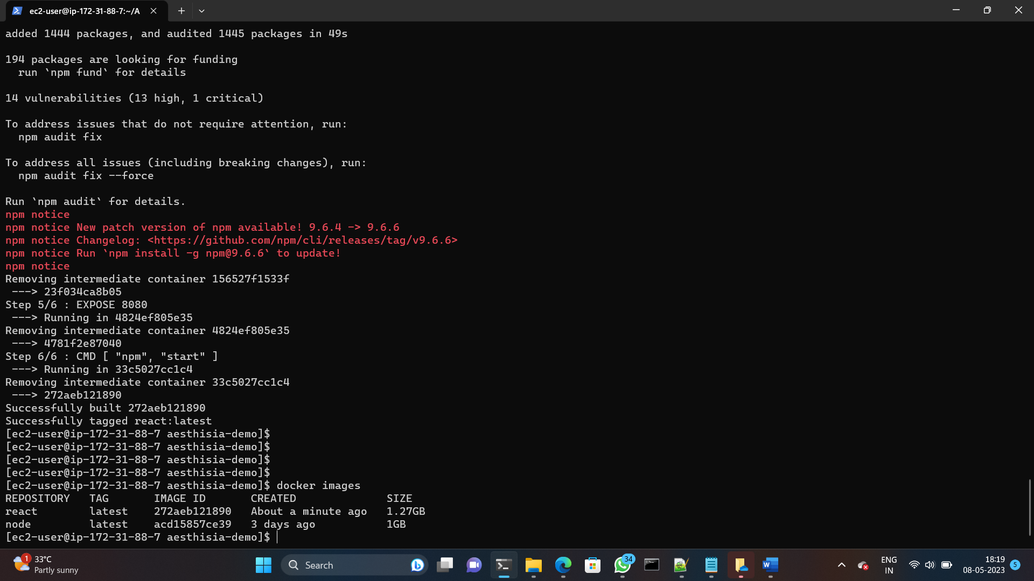

Successfully created the docker image .

1. After building the docker image run the following command the to start the docker container.
2. The command to create container from docker image is.

* **docker build -t -d --name npm -p 3000:3000 react**

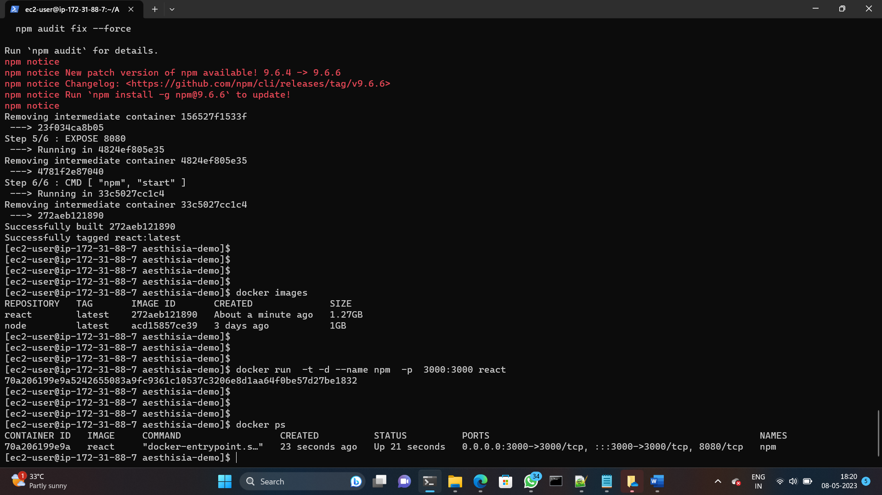

1. To see if container is successfully created or not run the **docker ps** command it will shows the running containers.
2. My docker container is successfully created you can see in the above image and Browse the app.
3. Once the docker container is running . you can browse the app by opening web browser and navigating to the public ip of your instance ,followed by the port 3000.

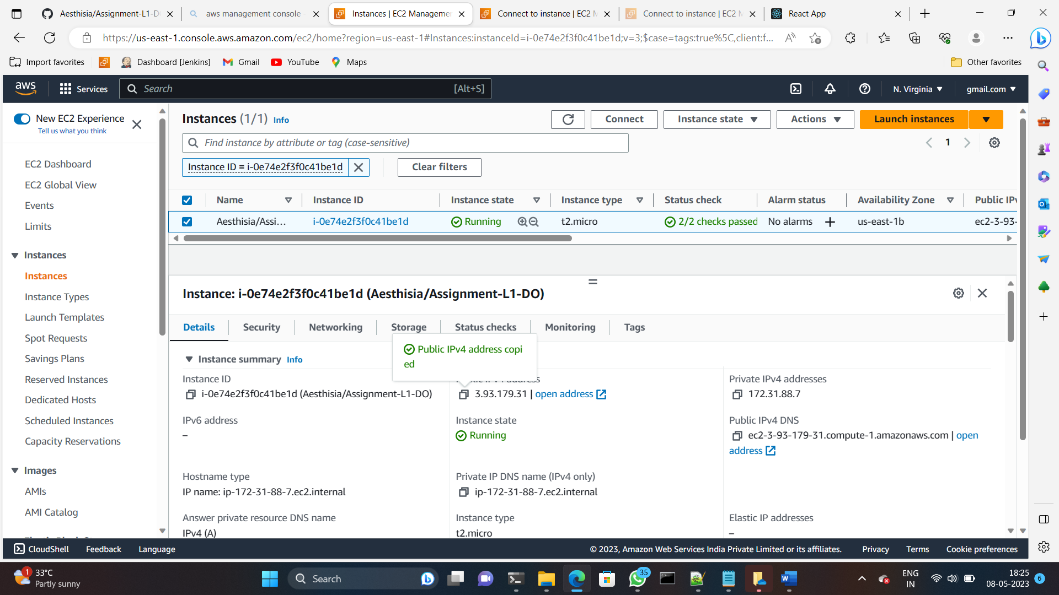

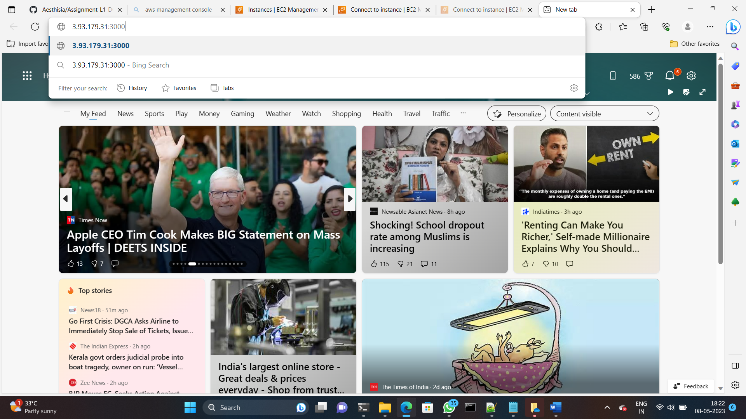

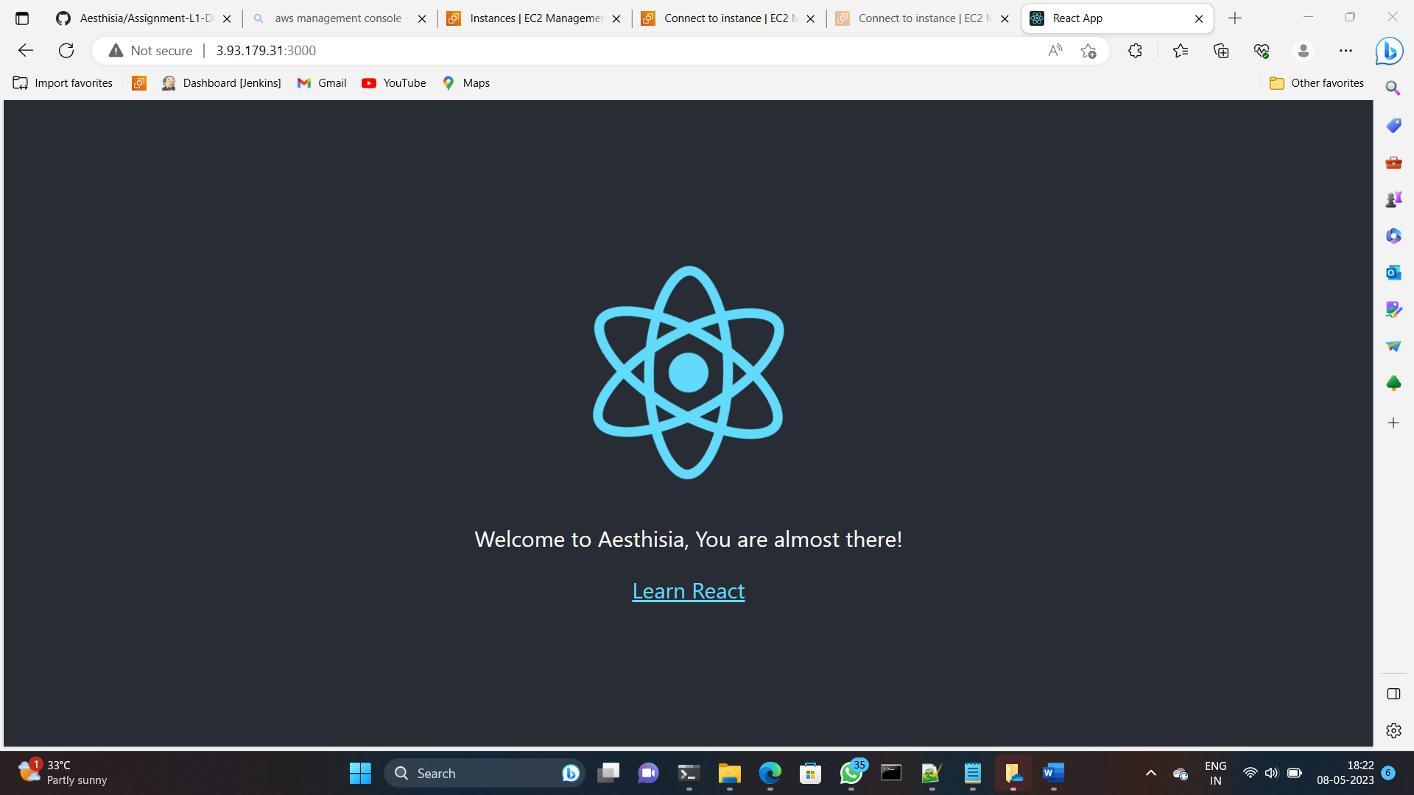

And the lastly , I had look to see that this was running correctly.

Thank you ,

**Shalini.K**